**5.4. Mouse scroll wheel**

If the RX window is full of text, and some text has scrolled off, you can pause the RX window by placing the Mouse cursor anywhere in the RX window and rotate the scroll wheel. This function will suppress incoming data, allowing the user to scroll the existing text without interruption by incoming text.  This pause function is visually indicated by the word “Freeze…” on the left side of the Sound card header. Freeze mode will time-out and self-cancel if no further scrolling is detected. If the cursor is moved away from the receive pane, freeze mode is immediately canceled and incoming text printing is resumed

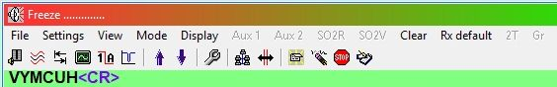

CWR_28

The “Freeze” function is enabled by checking “Enable receive freeze” Function” in the Rx window options.

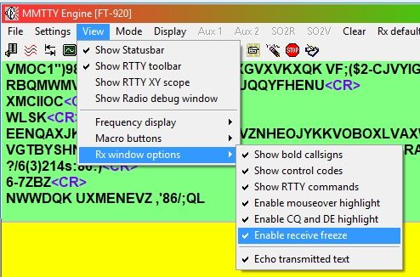

CWR_28A